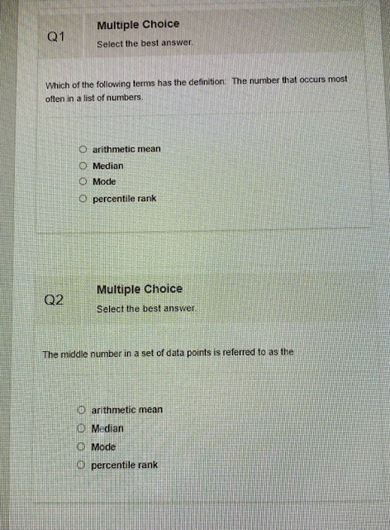
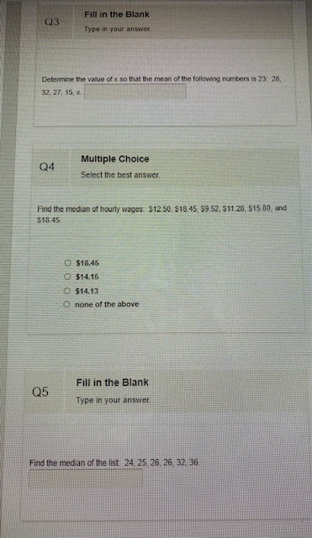
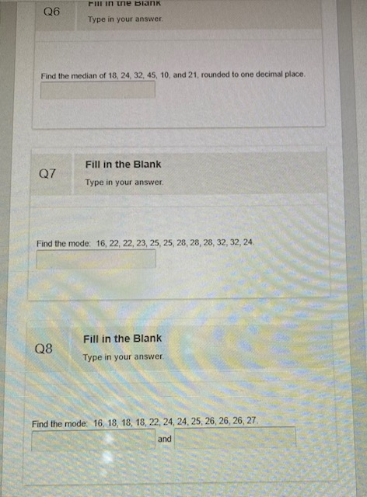
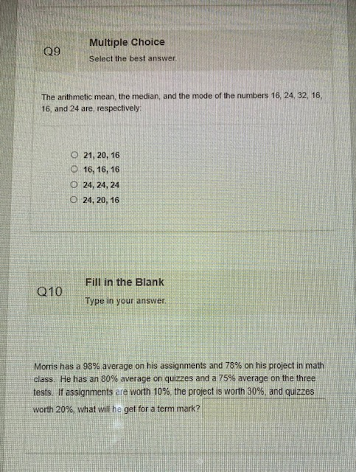
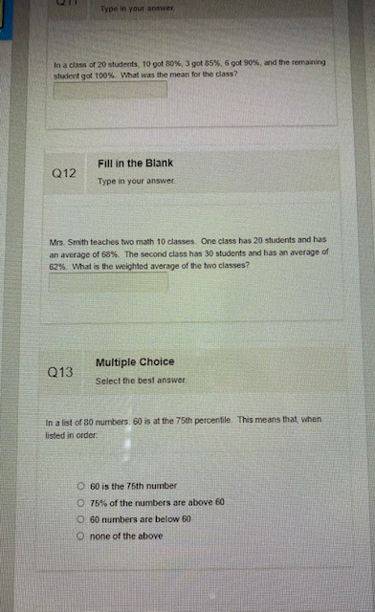
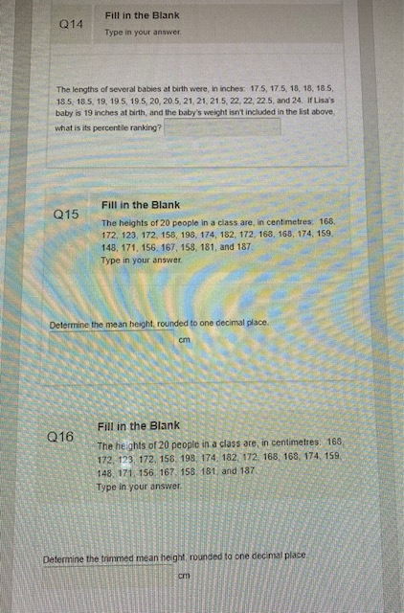
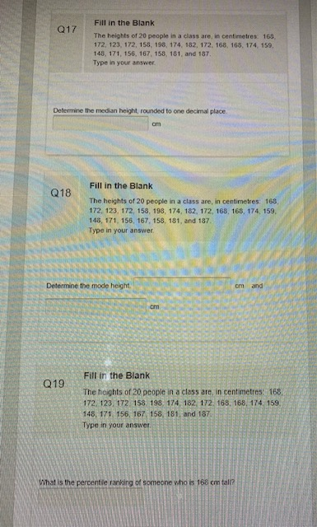
Answers:
1. C
2. B
3.13
4.17.125
5. 26
6.22.5
7.28
8.18,26
9. A
10.79.2
11.84.75
12.64.4%
13. B
14.36.84%
15.167.8
16. 169.5
17.169.5
18.168,172
19. 40%

